Job Description
Job Title | Disability Coordinator
Reports to (Title) | Head of Student Wellbeing
Department | Student and Academic Services
Hours of Work | 0.8 FTE
Salary Band (Manager, Head of Department etc.) | Manager
Salary range (£) | £30,000 - £35,000 pro rata
Length of role | Initially one year with extension possible

Prime Functions of Role
- To provide advice and guidance and organise support for students with a range of disabilities in order to facilitate their academic progression and enhance their student experience.
- To support and oversee non-medical helper and other specialist support arrangements.
- To manage the administration of Disabled Students’ Allowance (DSA) payments, records and audit requirements.
- To work closely with Course Directors, Lead Tutors and Heads of Department to support reasonable adjustments are made to learning, teaching and assessment practices.
- To provide pastoral support and general welfare advice to students.

Accountabilities & Tasks

Coordination of Disability Support
- To provide advice, guidance and support to disabled students throughout their training.
- To assess the level of support required by students, make recommendations and put in place support arrangements that are appropriate and individual to the student, in liaison with the Head of Student Wellbeing, the Deputy Registrar (Admissions and Student Services) and the Access and Participation Team.
- To liaise with the Student Loans Company and other relevant funding bodies regarding DSA and funding for specialist support.
- To act as an advocate in communication with RADA staff and external agencies as appropriate and agreed with the student.
- To liaise with the Student Wellbeing Service, Student and Academic Services and other RADA staff to offer guidance on student support requirements and reasonable adjustments in accordance with the Equality Act 2010.
- To oversee the coordination of non-medical helper (NMH) support including recruitment, appointment bookings, needs assessments, processing payments for freelance staff and monitoring the effectiveness of provision.
- To manage the booking and payment of BSL interpreters.
- To manage invoicing, record keeping and external audit of NMH support funded by DSA.
- To source and implement relevant assistive technologies.
- To create student Learning Agreements in cooperation with Course Directors and to maintain accurate records of these agreements..
- To coordinate and/or deliver disability awareness training and other related training opportunties for students and staff.

Student Advice
- To provide one-to-one advice for students on in areas such as finance, accommodation, employment and health.
- To refer students to specialists within the Student Wellbeing Service and to signpost other relevant internal and external services and resources.
- To assist students in communicating with external services (e.g. housing services, funding bodies, healthcare services).
- To assist students requiring individual support to complete appeals, complaints and mitigating circumstances forms.
- To arrange additional training and external advice in support of students’ welfare needs.
- Contribute to student induction processes, providing key advice and supporting new students to integrate into the RADA community.

General
- Promote equality, diversity and inclusion at all times and contribute to the development of a culture of inclusion and accessibility at RADA.
- Comply with data protection legislation, including the General Data Protection Regulations regarding protecting personal data.
- Comply with Health and Safety legislation and ensure you are up to date with RADA’s Health and Safety Policy.

By accepting a role at RADA, you acknowledge a commitment to RADA’s values and mission and a willingness to contribute to the ongoing development of the same.

Person Specification
 | Essential | Desirable
Qualifications | - Bachelor’s degree or equivalent professional experience. | - An SpLD certification  - Membership of a relevant professional body, e.g. PATOSS or ADSHE
Knowledge and skills | - Experience of working with young adults with disabilities and SpLDs preferably in Higher Education.  - Experience of liaising with external and internal parties about individual support requirements including funding.  - A thorough understanding of the impact of disability on the academic, social and personal life of students.  - Knowledge of Disability Student Allowance (DSA) application procedures  - Ability to develop appropriate strategies for study / training for students with SpLDs.  - Able to respond appropriately to students who present with sensitive issues, including appropriate referral to other services  - Have a strong commitment to practice informed by the principles of equity, accessibility and inclusion. | - Knowledge of assistive technology and facilitating access of information in alternative formats.  - Experience of delivering induction/briefing sessions for students and staff.  - Experience of managing staff  - Experience of establishing booking/appointment systems  - Experience of contributing to effective monitoring and evaluation of service
Communication Skills | - Is able to break down complex information and represent it according to individual requirements.  - Is able to maintain discretion and confidentiality.  - Is able to communicate with other staff members to ensure that the students’ needs are met.  - Able to work with minimal supervision.  - Excellent interpersonal, communication and organisational skills.  - Is able to establish and maintain productive working relationships  - Able to produce accurate and concise information at speed.  - Friendly and approachable
Other requirements | - A flexible approach to work and willingness to work around students’ timetables
Last updated: Jun 2022

Our purpose and values

RADA is dedicated to world-leading training in the dramatic arts.
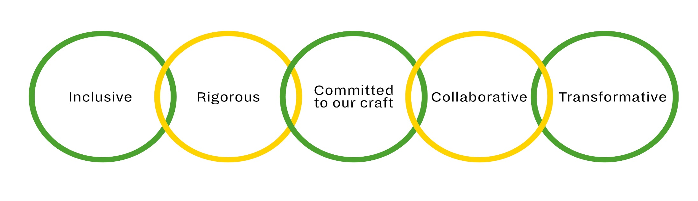

- We train talented people from all backgrounds.

- We provide financial support for students to address inequality in access to training.

- We create opportunities for people to encounter our training and expertise in many different ways.

- We challenge ourselves to provide the best possible training in an evolving industry.

- We use nationally recognised frameworks to underpin our world- leading conservatoire- level training and support services.

- We protect all RADA’s assets for the future, and maintain a fit-for- purpose estate and infrastructure supported by sustainable commercial initiatives.

- We uphold and champion standards of excellence in our craft.

- Our practice-based training provides students with access to the heritage of their craft while embracing contemporary practice and innovation.

- RADA was founded by the profession for the profession and we work with practising industry professionals to train the next generation.

- We teach collaborative disciplines, sustained by reflection and resilience.

- We uphold openness, curiosity, enquiry and experiment in our practice and in our artistic programme.

- We learn from and work with others, our students, our teachers and our community.

- We provide opportunities for artistic and personal transformation.

- Our impact is wider than dramatic arts training with benefits to society, business and communities young and old.

- We are a specialist institution that helps drive the creative industries and enhances Britain’s reputation abroad.

