Job Description

Job Title | Access and Participation Manager
Job Holder
Reports to (Title) | Director of Access and Participation
Reports to (Name) | Axa Hynes
Responsible for: | Freelance practitioners
Department | Access and Participation
Hours of Work | 30 hours per week (part time, 4 days a week)
Salary Band (Manager, Head of Department etc) | Manager
Salary range (£) | £30K
Length of role | Permanent
HESA Category (Professional Services, Academic etc) | Professional Services

Prime Functions of Role:

The Access and Participation Managers are responsible for designing, developing and delivering activity that will support RADA’s aspiration to recruit and train a diverse range of students. This will contribute to the strategy of the Access and Participation department and reaching targets set out in the Access and Participation plan.

Accountabilities & Tasks

- Academy Access and Participation Strategy
- To manage the planning, delivery and evaluation of strategies and activities associated with access and participation.
- To support with the development of strategies to reach under-represented groups within the conservatoire and theatre/arts sector to contribute to RADA’s objectives.
- To contribute to the development of policy and practice for student retention, in relation to the WP strategy.
- To work closely with the Admissions team, in the development of programmes connected to the admissions cycle, advise on new venues and build local relationships to support the widening access to RADA’s HE programmes.
- To contribute to developing financial support schemes for participants in the WPO programme.
- To be a link with external bodies and agencies for WPO activity and to support in managing the relationship with the Office for Students in relation to access and participation work.

- Management of Access and Participation team
- Contribute to the team by working alongside the other Access and Participation Manager
- Management of freelance practitioners.
- Ensure compliance with RADA’s HR requirements.
- Manage project budgets and feed into overall team budget
- Work closely with colleagues across the Academy to deliver an effective access and participation service.

Project development delivery
  - To deliver Access and Participation related projects, via in person and online sessions, alongside freelance facilitators.
  - To contribute to the creation and management of WPO projects, including recruiting project leaders and managing and supporting them in planning and delivering project work.
  - To produce public facing (digital and/or live) events that showcase the Access and Participation work
  - To manage project budgets, process payroll and approve invoices for tutors and graduates employed to deliver sessions.
  - To work with the Development Department to identify opportunities for financial support for access and retention work.
  - To work with the Short Courses team to develop programmes which might include a WP element or to make Short Courses accessible to students from WP backgrounds.
  - To work with the Marketing Department to create print, website copy and social media content for targeted audiences to attend courses and workshops.

- Equality, Diversity, Inclusion and Anti-Racism

  - To contribute to RADA’s Equality, Diversity and Inclusion Strategy.
  - To contribute to the progress of RADA’s Anti-Racism action plan
  - To participate in regular training in order to stay up to date with current thinking and progression in Equality, Diversity and Inclusion.
  - To imbed best practice into all areas of the Access and Participation department
  - To support the Director of Access and Participation where necessary on the above.

- Manage relationships
  - To build a network of relationships with schools, colleges, other HE providers and arts organisations to deliver RADA’s Access and Participation Plan and WPO Strategy.
  - To deliver or enable delivery of activity with partner organisations (for example progression agreements, sponsorship arrangements, joint projects, careers talks, outreach events).
  - To work with the HE student body in developing new WPO initiatives, including consultation and engagement in the programme.
  - To contribute to training for members of the Audition/Interview/Admissions Panels.
  - To act as a Designated Safeguarding Lead for Access and Participation work and to deputise for the Director of Access and Participation in RADA’s Safeguarding Group.
  - To be a member of any other sector access and participation groups as appropriate or required by the Access and Participation Director

- Monitoring and evaluation
  - To establish effective systems of monitoring and evaluation of the impact of WP activity, including longitudinal studies, both independently and in liaison with CDD and other HE/arts sector bodies.
  - To contribute to annual reports about progress in relation to widening participation and access progress for RADA.
  - To work with the Director of Access and Participation and colleagues in Student and Academic Services to produce statistical analyses of student populations and to track WP student progress.
- General
  - Keep up to date with current thinking in widening participation, access and retention work within higher education and arts policy around participation work.
  - Ensure effective communication with students in liaison with other members of the department (newsletters, notice boards, emails, hosting feedback sessions with students).
  - Deputise for the Director of Access and Participation as required.
  - Participate in any RADA-wide management groups as required.
  - Undertake any other duties commensurate with the role.
  - Promote equality, diversity and inclusion at all times and ensure they are at the forefront of your thinking when undertaking your responsibilities.
  - Comply with Health and Safety legislation and ensure you are up to date with RADA’s Health and Safety Policy.
  - Comply with GDPR, Data Protection, Safeguarding legislation and Respect at RADA policy.
  - Contribute to the development and culture of RADA, attend RADA training and staff events as and when required (including but not limited to annual staff conference and termly town hall meetings).

By accepting a role at RADA you are acknowledging a commitment to RADA’s values and mission, and a willingness to contribute to the ongoing development of the same.

Person Specification

 | Essential | Desirable
Knowledge and experience | - A minimum of 2 years’ experience either managing or coordinating arts projects for young people.  - Knowledge and experience of access and participation work in the arts, ideally theatre.  - Knowledge and experience of designing and managing courses for young people.  - Knowledge and experience of conducting evaluations of access and participation programmes.  - Experience of working in partnership arrangements.  - Experience of working with young people from under represented backgrounds | - Experience of organising widening participation activity within (or in partnership with) higher education.  - Experience of creating partnerships with schools, colleges, theatres or other arts organisations.
Skills/abilities/  Competencies | - Excellent command of written and spoken English, including writing strategies, policies and reports.  - Numerate and able to produce and interpret statistical information and manage budgets.  - Excellent IT skills, using Microsoft Office packages and experience of database use. | - Experience in a role with some element of leadership.
Qualifications | - An undergraduate degree or equivalent qualification in the Arts or relevant equivalent experience. | - Relevant degree in drama or degree incorporating relevant teaching or workshop-leading skills.
Personal Attributes | - A demonstrable commitment to equality, diversity and inclusion and delivering projects that will support this.  - An effective and collaborative team member.  - Ease and confidence in working with others from children to sector-leaders.  - The ability to persuade others and take them with you to achieve a vision.

Signed by Line Manager:
Date:

Signed by Staff Member:
Date:

Last updated: 24 August 2020

Our purpose and values

RADA is dedicated to world-leading training in the dramatic arts.
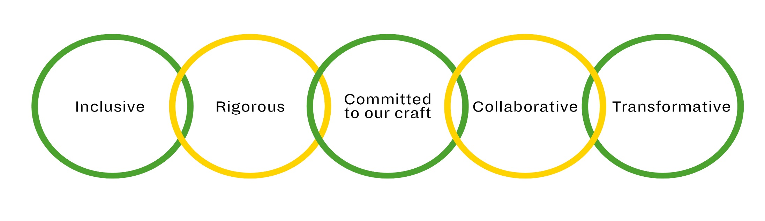

- We train talented people from all backgrounds.
- We provide financial support for students to address inequality in access to training.
- We create opportunities for people to encounter our training and expertise in many different ways.
- We challenge ourselves to provide the best possible training in an evolving industry.
- We use nationally recognised frameworks to underpin our world- leading conservatoire- level training and support services.
- We protect all RADA’s assets for the future, and maintain a fit-for- purpose estate and infrastructure supported by sustainable commercial initiatives.
- We uphold and champion standards of excellence in our craft.

- Our practice-based training provides students with access to the heritage of their craft while embracing contemporary practice and innovation.
- RADA was founded by the profession for the profession and we work with practising industry professionals to train the next generation.

- We teach collaborative disciplines, sustained by reflection and resilience.
- We uphold openness, curiosity, enquiry and experiment in our practice and in our artistic programme.
- We learn from and work with others, our students, our teachers and our community.

- We provide opportunities for artistic and personal transformation.
- Our impact is wider than dramatic arts training with benefits to society, business and communities young and old.
- We are a specialist institution that helps drive the creative industries and
- enhances Britain’s reputation abroad.

