

**Job Description**

|  |  |
| --- | --- |
| **Job Title** | Wigs, Hair and Make up Tutor |
| **Job Holder** |  |
| **Reports to (Title)** | Head of Wardrobe |
| **Reports to (Name)** | Kyriaki Bouska |
| **Responsible alongside (staff)** | Deputy Head of Wardrobe, Assistant Head of Wardrobe |
| **Department** | Costume |
| **Hours of Work** | Part time (0.5 FTE, 18.75 hours per week) |
| **Salary Band (Manager, Head of Department etc)** | Tutor |
| **Salary range (£)** | Pro rata of xxxxxx per annum |
| **Length of role** | Permanent |
| **HESA Category (Professional Services, Academic etc)** | Academic |

|  |
| --- |
| **Prime Functions of Role:** |
| To take a prime role in the delivery of WHAM and delivering a series of classes to both Acting and Technical Students in the area of Hair and make-up with Afro, curly and straight hair and all skin tones. |

|  |
| --- |
| **Accountabilities & Tasks** |
| TEACHING   * Partake in initial one-to-one sessions with Acting Students with a view to gaining knowledge of skin and hair requirements and liaising with wardrobe to further develop their stock of products. * Develop methods of equipping students with sensitivity, communication skills and technical language with relation to afro and textured hair, allowing Black acting students to feel at ease in the Wardrobe Department. * Carrying out basic sessions with the Acting students in skin and hair care, patch testing and colour matching, advice on creating a make up kit and advice on basic hair styling. * Carrying out sessions with the technical students in basic hair and make up skills, and the post graduate students in applying facial hair, wig knotting and period hair styling, and etiquette whilst working with actors with their hair and make up. * Mentor students in individual show projects. * Assist in the Assessment Process of the students. * Support and encourage by example, the highest educational and professional standards – the needs and general wellbeing of students on courses and at all levels within the Academy. * Ensure teaching practice remains up to date and in line with industry and RADA expectations through participating in some or all of RADA-based training, CPD, research, ongoing professional practice as appropriate.   **PRODUCTION DUTIES**   * Supporting the Costume department to facilitate the WHAM requirements of the Academy’s in-house productions, as well as 2nd year acting presentations when required. * Liaise with the Costume staff team, in order to have an overview and understanding of the WHAM requirements for the shows. * Organize and lead WHAM fitting sessions for the Academy's productions, offering guidance and technical support to the acting students, designers and Costume Supervisor students. * Attend, when needed, white card and production meetings. * Attend and support, when needed, the Technical rehearsals advising on the WHAM requirements of the shows and to pass on the methods to the Supervisors or Technical students who will then continue the application through the show run. * To be responsible and manage the WHAM budget for the Academy’s productions. * To partake in show staff duties with the rest of the Costume staff.   **RESOURCE MANAGEMENT**   * Help develop classes with the PgDip Costume students and 2nd/3rd year TTSM students to enhance their knowledge in Hair and Make Up within the skills of Supervisors. * Help develop a programme in support of the Acting students in both the BA and MA areas. * Liaise with Wardrobe to ensure the stock of hair and make-up products are adequate and current. * Develop contacts/partnerships with hairdressers/wig and weave specialists to enable delivery of the required hair styles.   DECISION MAKING   * Discuss ways of delivering Afro hair sensitivity training which can be extended to all staff and students at RADA. * Attend departmental meetings, and other meetings as appropriate.   STAKEHOLDER/ NETWORKS   * Liaise with the Directors/designers of the 3rd year BA acting shows in creating hair and make-up styles and to pass on the styles to the Supervisors or staff members who will then continue the styling through the show run. * Liaise with RADA sponsors to gain the correct products for the department.   **GENERAL**   * Take on any additional duties and responsibilities that may be reasonably expected within the terms of contract. * Contribute to the development and culture of RADA. * Attend RADA training and staff events as and when required (including but not limited to annual staff conference and termly town hall meetings). * Promote Equality, Diversity and Inclusion at all times and ensure they are at the forefront of your thinking when undertaking your responsibilities. * Comply with GDPR regulations regarding protecting personal data. * Comply with Health and Safety legislation and ensure you are up to date with RADA’s Health and Safety Policy.   By accepting a role at RADA you are acknowledging a commitment to RADA’s values and mission, and a willingness to contribute to the ongoing development of the same. |

**Person Specification**

|  |  |  |
| --- | --- | --- |
|  | **Essential** | **Desirable** |
| **Knowledge and experience** | * Knowledge of the work within a theatrical environment including applying and styling wigs. * Good knowledge of working with Afro, curly and straight hair. * Several years’ experience in a theatrical environment in the area of hair and make-up. * Knowledge and experience of how to communicate with people regarding hair texture and techniques, using the correct terminology. * Understanding the grades of textured hair and the care of the hair and scalp * Understanding of chemicals such as relaxers, texturisers and colour. * An understanding of tools for textured hair and how to use them. | * Period hair styling * Work on films/video |
| **Skills/abilities/**  **Competencies** | * A high level of skill in styling and maintaining Afro and textured hair. * The ability to match and apply make-up to all skin tones. * Safe and comfortable preparation of hair for styling and for wig application | * FX make up skills |
| **Qualifications** |  | * Specialist qualifications within the discipline. * Clear and evidence of extensive experience in the subject. |
| **Personal Attributes** | * A calm and personable disposition. * A willingness to work evenings and some weekends. |  |

Signed by Line Manager:

Date:

Signed by Staff Member:

Date:

Last updated:

**Our purpose and values**

RADA is dedicated to world-leading training in the dramatic arts.

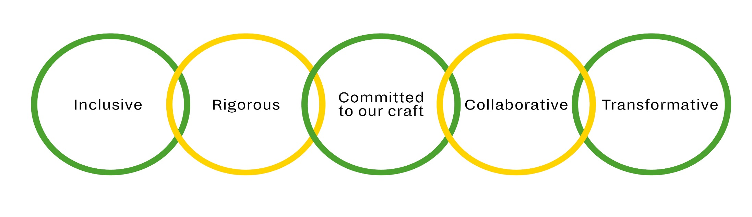

* We train talented people from all backgrounds.
* We provide financial support for students to address inequality in access to training.
* We create opportunities for people to encounter our training and expertise in many different ways.
* We challenge ourselves to provide the best possible training in an evolving industry.
* We use nationally recognised frameworks to underpin our world- leading conservatoire- level training and support services.
* We protect all RADA’s assets for the future, and maintain a fit-for- purpose estate and infrastructure supported by sustainable commercial initiatives.
* We uphold and champion standards of excellence in our craft.
* Our practice-based training provides students with access to the heritage of their craft while embracing contemporary practice and innovation.
* RADA was founded by the profession for the profession and we work with practising industry professionals to train the next generation.
* We teach collaborative disciplines, sustained by reflection and resilience.
* We uphold openness, curiosity, enquiry and experiment in our practice and in our artistic programme.
* We learn from and work with others, our students, our teachers and our community.
* We provide opportunities for artistic and personal transformation.
* Our impact is wider than dramatic arts training with benefits to society, business and communities young and old.
* We are a specialist institution that helps drive the creative industries and enhances Britain’s reputation abroad.